**Lab No.4**

01. Write a C program to input a character from user and check whether given character is small alphabet, capital alphabet, digit or special character, using if else.

#include <stdio.h>

#include <stdlib.h>

int main()

{

char a;

printf("Enter any character: ");

scanf("%c", &a);

if (a >= 'A' && a <= 'Z'){

printf("This Is Capital Letter of Alphabet.");

}

else if (a >= 'a' && a <= 'z'){

printf("This Is Small Letter of Alphabet.");

}else if (a >= '0' && a <= '9') { **Out put:**

printf("This Is A Digit.\n");

}

else {

printf("This Is A Special Character.\n");

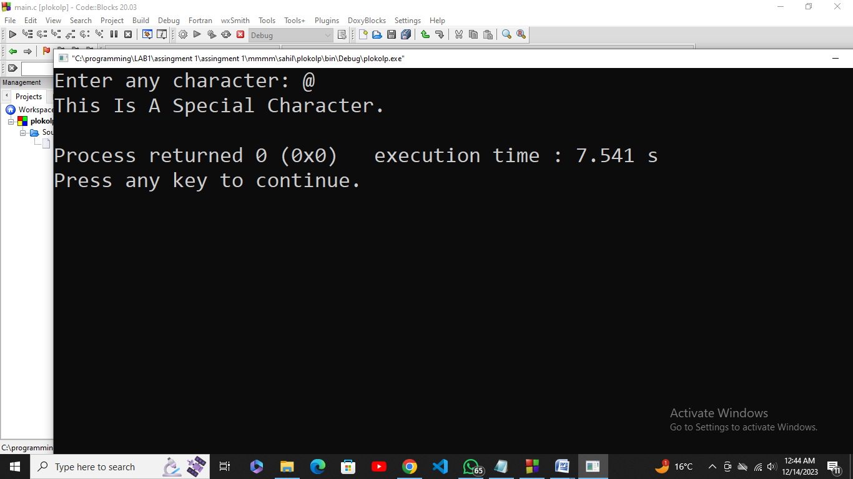

}

return 0;

}

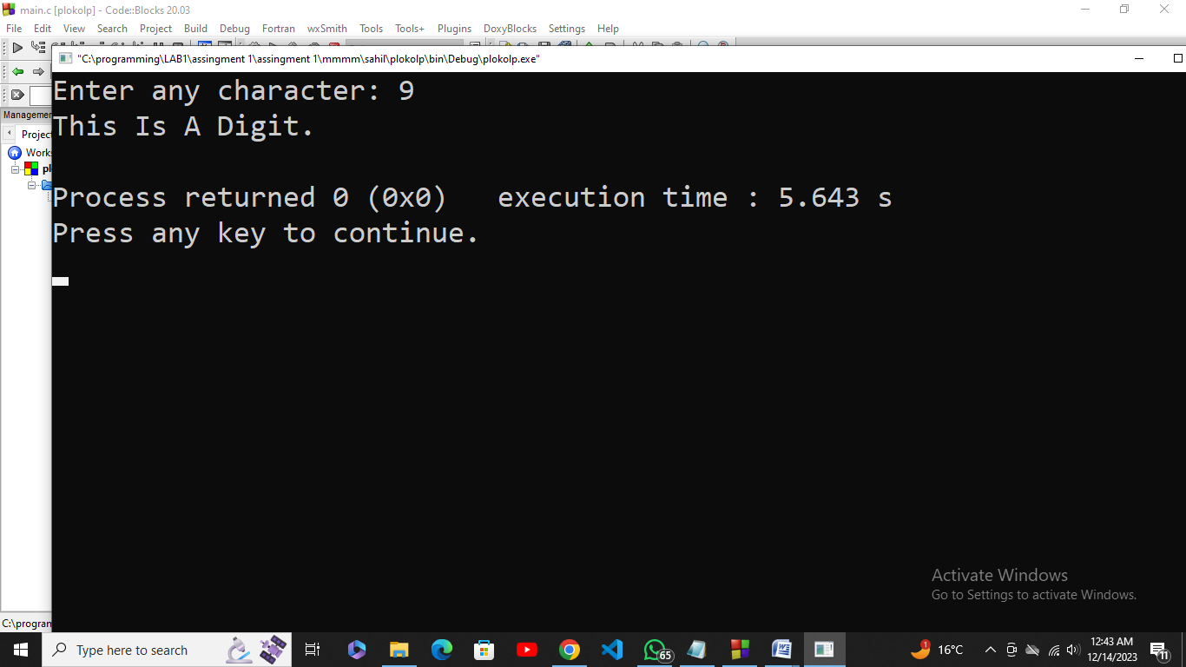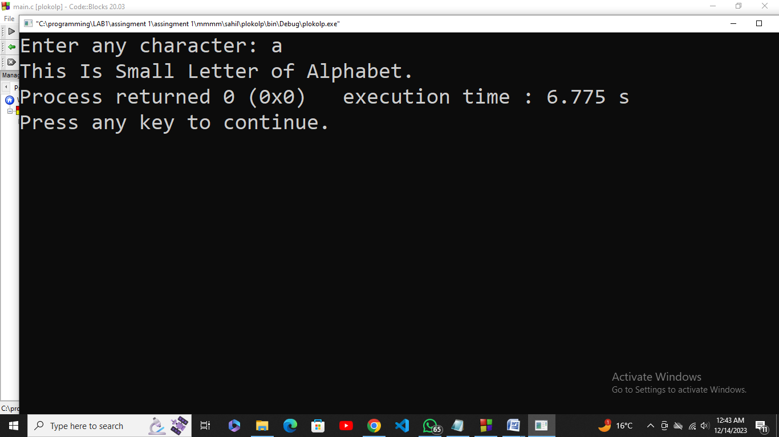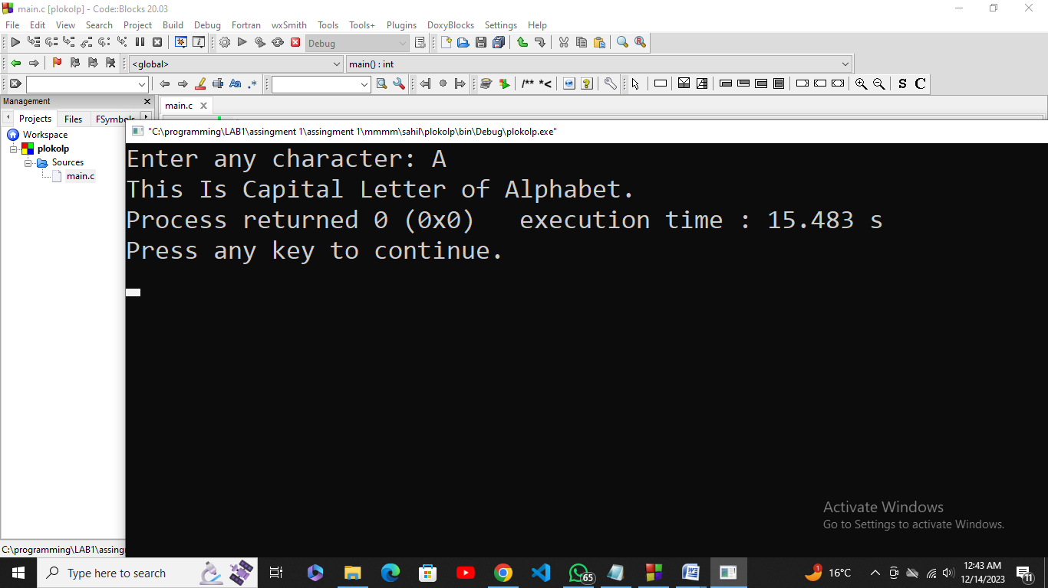

02. Write a C program to receive an 8-bit number into a variable and then check if its 4th and 7th bits are on. If these bits are found to be on, then put them off.

#include <stdio.h>

#include <stdlib.h>

int main() {

unsigned char num;

printf("Enter an 8-bit number: ");

scanf("%hhu", &num);

printf("Number in binary: ");

for (int i = 7; i >= 0; --i) {

printf("%d", (num >> i) & 1);

}

printf("\n");

if ((num & (1 << 3)) && (num & (1 << 6))) {

num &= (1 << 3);

num &= (1 << 6);

printf("4th and 7th bits turned off.\n");

} else {

printf("No action needed.\n");

}

printf("Modified number in binary: ");

for (int i = 7; i >= 0; --i) {

printf("%d", (num >> i) & 1);

}

printf("\n");

**Out put:**

return 0;

}

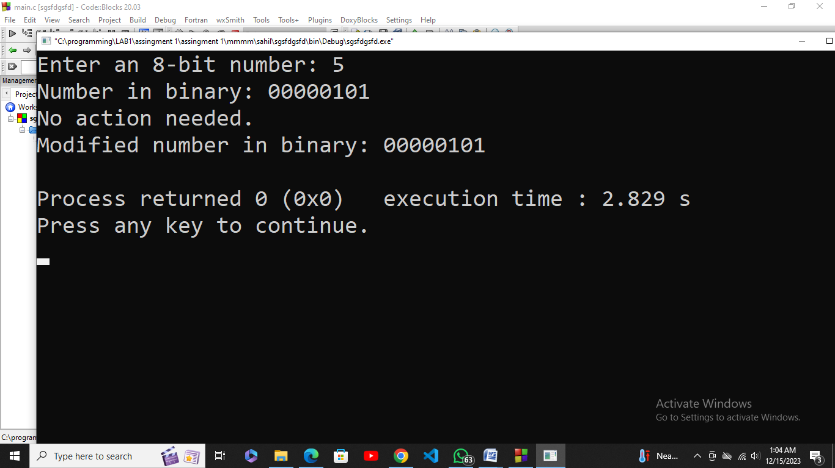

03. An online shopping store is providing discounts on the items due to the Eid. If the cost of items is more than 1999 it will give a discount upto 50%. If the cost of shopping is 2000 to 4000, a 20% discount will be applied. If the cost of shopping is 4001 to 6000, a 30% discount will be applied. If it's more than 6000 then 50% discount will be applied to the cost of shopping. Print the actual amount, saved amount and the amount after discount.

#include <stdio.h>

#include <stdlib.h>

int main() {

float v, perc;

printf("Enter The Value Of Item: ");

scanf("%f", &v);

if (v>=2000 && v<=4000){

perc = v*20/100;

}else if (v>4000 && v<=6000){

perc = v*30/100;

}else if(v>6000){

perc = v*50/100;

}else {

printf("This Offer Is Only For Them Who's Item's Price Is Above 1999.");

}

printf("Actual Amount = %.2f\n", v);

printf("Saved Amount = %.2f\n", perc);

printf("Amount After Discount = %.2f\n", v-perc);

return 0;

} **Out put:**

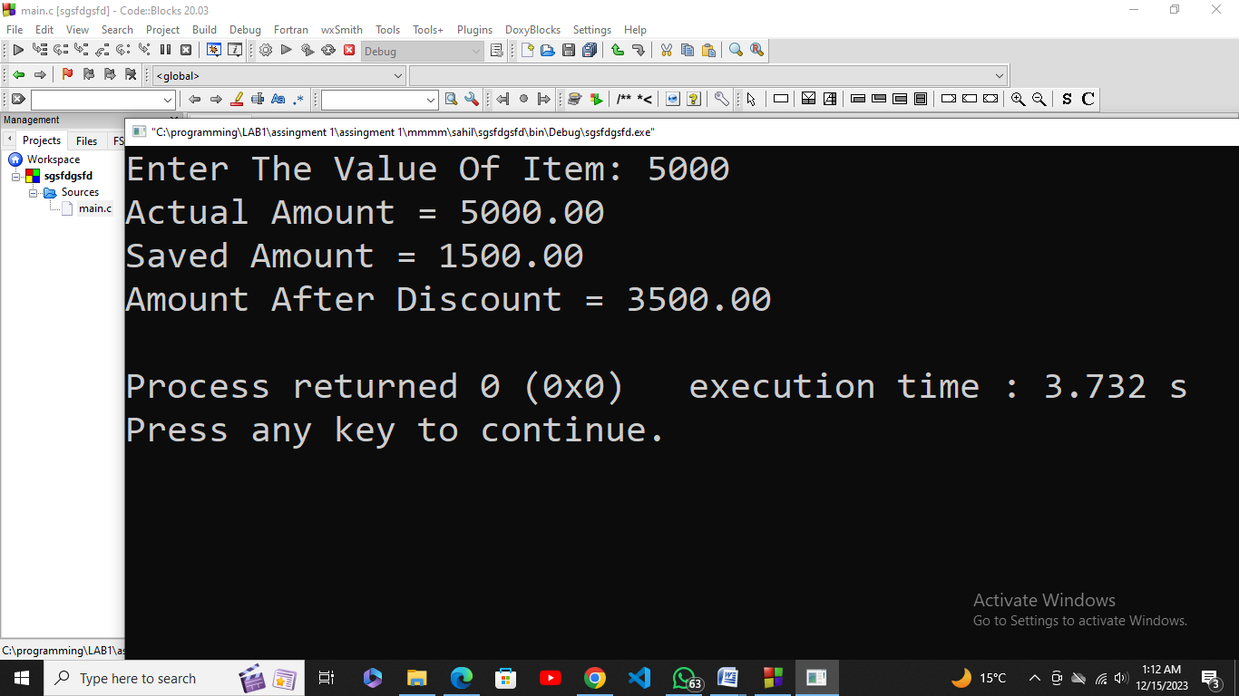

04. Write a C program to find all roots of a quadratic equation by using the given formula; it is required to take user input for a, b and c values.

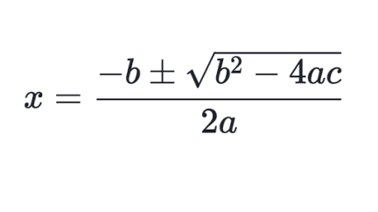

#include <stdio.h>

#include <stdlib.h>

int main() {

float a, b, c, discriminant, root1, root2;

printf("Enter coefficient a: ");

scanf("%f", &a);

printf("Enter coefficient b: ");

scanf("%f", &b);

printf("Enter coefficient c: ");

scanf("%f", &c);

discriminant = b * b - 4 * a * c;

if (discriminant > 0) { **Out put:**

root1 = (-b + sqrt(discriminant)) / (2 * a);

root2 = (-b - sqrt(discriminant)) / (2 * a);

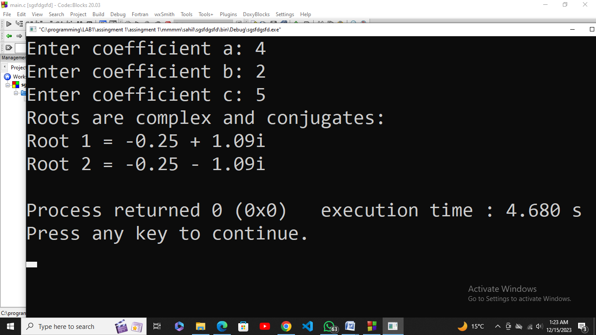

printf("Roots are real and distinct:\n");

printf("Root 1 = %.2f\n", root1);

printf("Root 2 = %.2f\n", root2);

} else if (discriminant == 0) {

root1 = -b / (2 * a);

printf("Roots are real and repeated:\n");

printf("Root 1 = Root 2 = %.2f\n", root1);

} else {

float realPart = -b / (2 * a);

float imaginaryPart = sqrt(-discriminant) / (2 * a);

printf("Roots are complex and conjugates:\n");

printf("Root 1 = %.2f + %.2fi\n", realPart, imaginaryPart);

printf("Root 2 = %.2f - %.2fi\n", realPart, imaginaryPart);

}

return 0;

}

05. Teacher asks the student to check whether the input number is divisible by 7 or not. For checking the divisibility, take the last digit and double it, take the rest of the digits and subtract the doubled last digit repeat until the result is 7, -7 or 0. For example:

10976 -> 1097-12 = 1085 -> 108-10 = 98 -> 9-16 = -7

49 -> 4 - 18 = 14 -> 1 - 8 = -7

#include <stdio.h>

int main() {

int a,b,c,d,e,f,g;

printf("Value Must Be 100 to 999.\n");

printf("Enter Value Of 'A': ");

scanf("%d", &a);

b = a % 10;

c = b+b;

d = a/10-c;

e = d % 10;

f = e+e; **Out put:**

g = d/10-f;

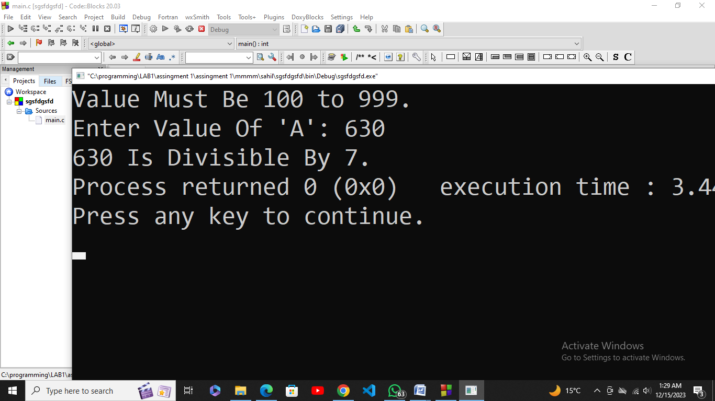

if(g == 0 || g == 7 || g == -7){

printf("%d Is Divisible By 7.",a);

}

else{

printf("%d Is Not Divisible By 7.",a);

}

return 0;

}

06. Write a program that asks for the number of **calories** and **fat grams** in a food.  The program should display the percentage of calories that come from fat.  If the calories from fat are less than 30% of the total calories of the food, it should also display a message indicating that the food is low in fat. One gram of fat has 9 calories, so Calories from fat = fat grams * 9. The percentage of calories from fat can be calculated as: calories from fat/total calories

**Input validation:** Make sure the number of calories and fat grams are not less than 0. Also, the number of calories from fat cannot be greater than the total number of calories.  If that happens, display an error message indicating that either the calories or fat grams were incorrectly entered.

#include <stdio.h>

int main() {

float calories, fatGrams, caloriesFromFat, percentageOfCaloriesFromFat;

printf("Enter the number of calories: ");

scanf("%f", &calories);

printf("Enter the number of fat grams: ");

scanf("%f", &fatGrams);

if (calories < 0 || fatGrams < 0) {

printf("Error: Calories and fat grams cannot be less than 0.\n");

return 1;

if (caloriesFromFat > calories) {

printf("Error: Calories from fat cannot be greater than total calories.\n");

return 1;

}

}

caloriesFromFat = fatGrams * 9;

percentageOfCaloriesFromFat = (caloriesFromFat / calories) * 100;

printf("\nPercentage of calories from fat: %.2f%%\n", percentageOfCaloriesFromFat);

if (percentageOfCaloriesFromFat < 30) {

printf("This food is low in fat.\n"); **Out put:**

}

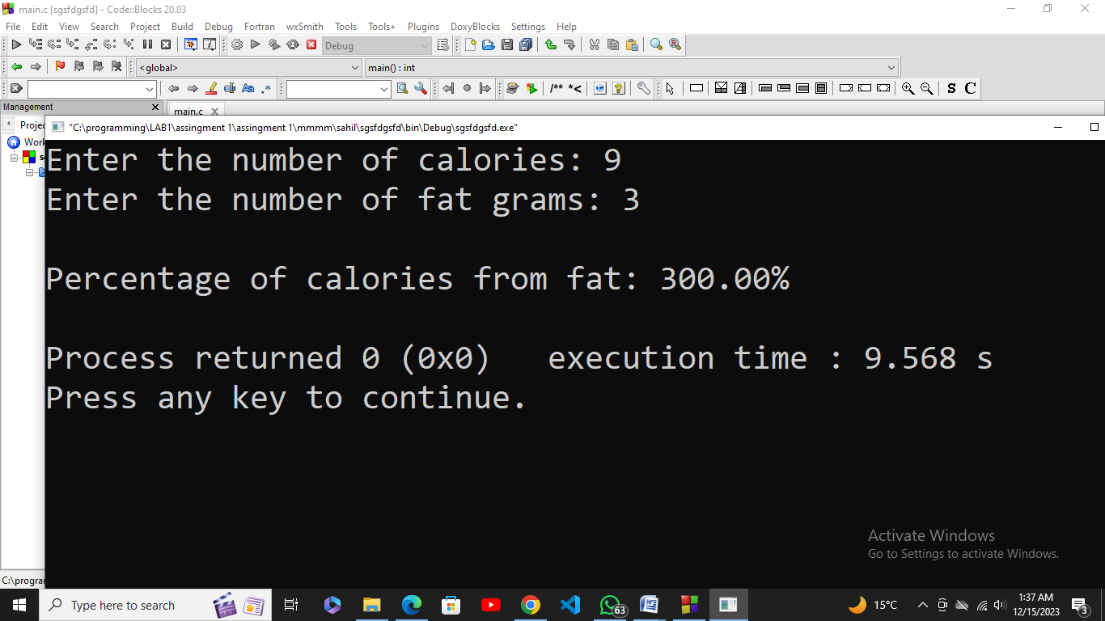

return 0;

}